Chimzim Ogbondah

Lofti Ben Othmane

SE 339

15 February 2021

Participation 3

1.)

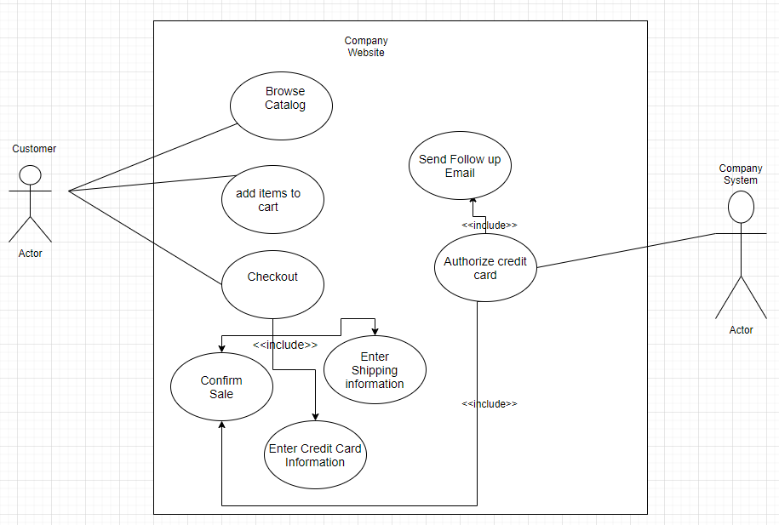

2.)

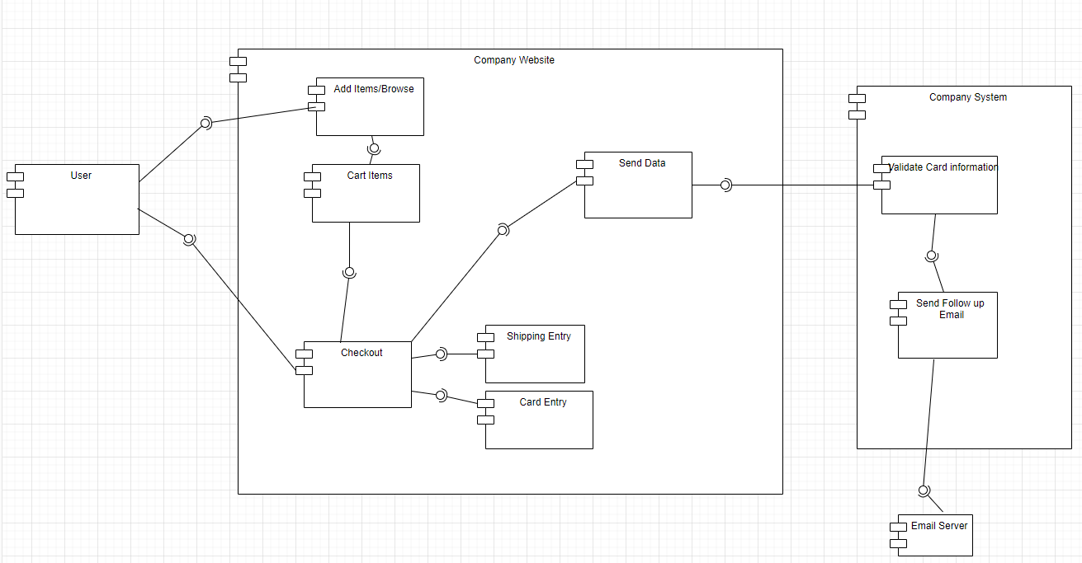

3.)

